**Furniture Assembly and Repair**

**Ikea Assembly** 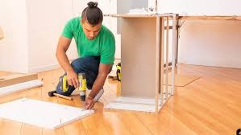

**Couch/Chair Repair** 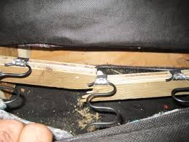

**Table repair, refinish** 